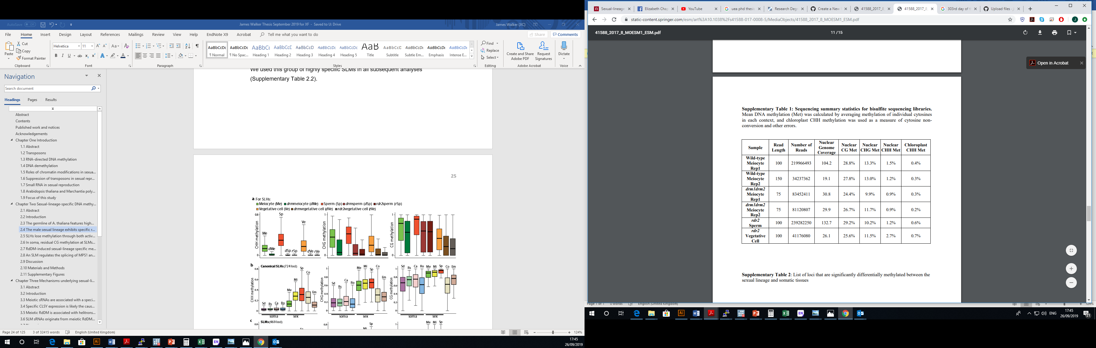Supplementary Table 2.1: Sequencing summary statistics for bisulfite sequencing libraries. Mean DNA methylation (Met) was calculated by averaging methylation of individual cytosines in each context, and chloroplast CHH methylation was used as a measure of cytosine nonconversion and other errors.